11g Grid Infrastructure (RAC): CRS Startup Sequence:

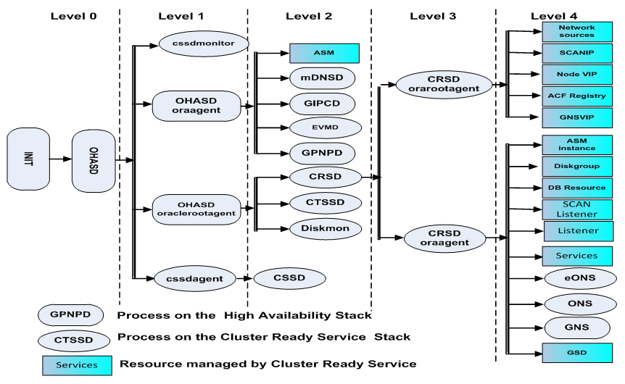
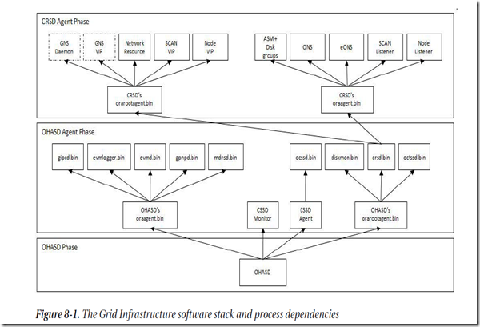

OHASD Phase:-
- OHASD (Oracle High Availability Server Daemon) starts Firsts and it will start .
OHASD Agent Phase:-
- OHASD Agent starts and in turn this will start
gipcd | Grid inter-process communication daemon, used for monitoring cluster interconnect
mdnsd | Multicast DNS service It resolves DNS requests on behalf of GNS
gns | The Grid Naming Service (GNS), a gateway between DNS and mdnsd, resolves DNS requests
gpnpd | Grid Plug and Play Daemon, Basically a profile similar like OCR contents stored in XML format in $GI_HOME/gpnp/profiles/<peer> etc., this is where used by OCSSD also to read the ASM disk locations to start up with out having ASM to be up, moreover this also provides the plug and play profile where this can be distributed across nodes to cluster
evmd/  evmlogger | Evm service will be provided by evmd daemon, which is a information about events happening in cluster, stop node,start node, start instance etc.
- cssdagent (cluster synchronization service agent), in turn starts
ocssd | Cluster synchronization service daemon which manages node membership in the cluster
If cssd found that ocssd is down, it will reboot the node to protect the data integrity.

- cssdmonitor (cluster synchronization service monitor), replaces oprocd and provides I/O fencing

- OHASD orarootagent starts and in turn starts
crsd.bin | Cluster ready services, which manages high availability of cluster resources , like stopping , starting, failing over etc.
diskmon.bin | disk monitor (diskdaemon monitor) provides I/O fencing for exadata storage
octssd.bin | Cluster synchronization time services , provides Network time protocol services but manages its own rather depending on OS
CRSD Agent Phase:- crsd.bin starts two more agents
crsd orarootagent(Oracle root agent) starts and in turn this will start
gns | Grid interprocess communication daemon, used for monitoring cluster interconnect
gns vip | Multicast DNS service It resolves DNS requests on behalf of GNS
Network | Monitor the additional networks to provide HAIP to cluster interconnects
Scan vip | Monitor the scan vip, if found fail or unreachable failed to other node
Node vip | Monitor the node vip, if found fail or unreachable failed to other node
crsd oraagent(Oracle Agent) starts and in turn it will start (the same functionality in 11gr1 and 10g managed by racgmain and racgimon background process) which is now managed by crs Oracle agent itself.
·
ASM & disk groups | Start & monitor local asm instance
ONS | FAN feature, provides notification to interested client
eONS | FAN feature, provides notification to interested client
SCAN Listener | Start & Monitor scan listener
Node Listener | Start & monitor the node listener (rdbms?)

